Category | Item | Photograph | Replacement cost as of 31/03/23
General Village  The Cricket Green | Wooden Bench (1/5) | 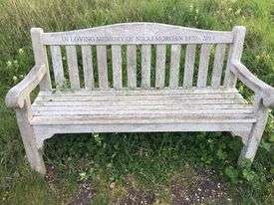 | £330
General Village  Station Road | Wooden Bench (2/5) | 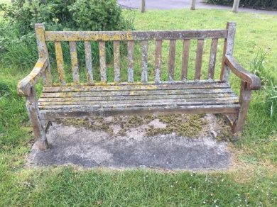 | £330
General Village  The Wick | Wooden Bench (3/5) | 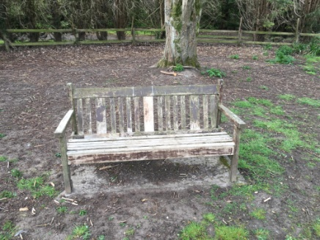 | £330
General Village  The Wick | Wooden Bench (4/5) | 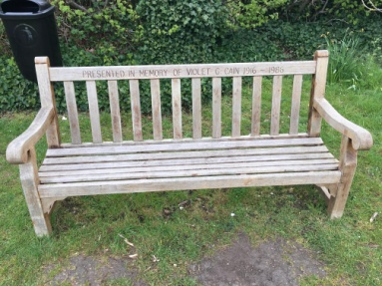 | £330
Category | Item | Photograph | Replacement cost as of 31/03/23
General Village  Royston Road | Wooden Bench (5/5) | 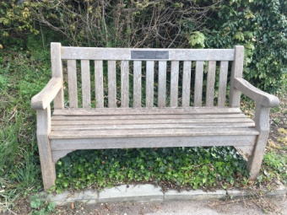 | £330
General Village  The Wick | Stone seat | 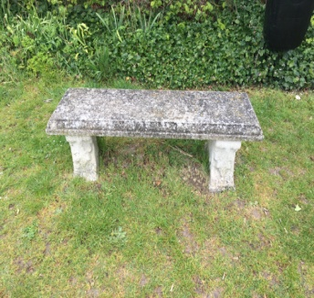 | £440
General Village  The Wick | Black waste bin  (1/6) | 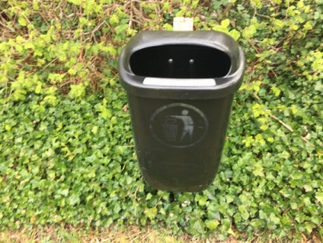 | £160
General Village  Duck Street | Black waste bin  (2/6) | 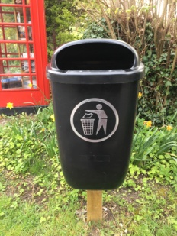 | £160
Category | Item | Photograph | Replacement cost as of 31/03/23
General Village  Royston Road | Black waste bin  (3/6) |  | £160
General Village  Station Road | Black waste bin  (4/6) | 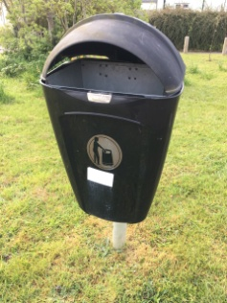 | £75
General Village  B1383  Bottom Rookery Lane | Black waste bin  (5/6) | 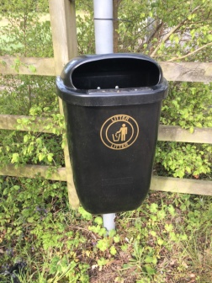 | £75
General Village  Royston Road | Black waste bin  (6/6) | 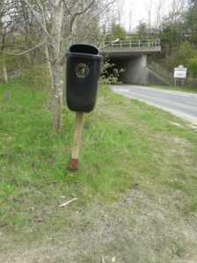 | £75
Category | Item | Photograph | Replacement cost as of 31/03/23
General Village  Dodna Lane | Bollard | 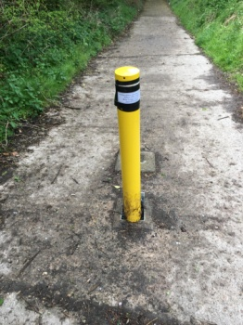 | £190
General Village  Cambridge Road | Black waste bin on bus shelter | 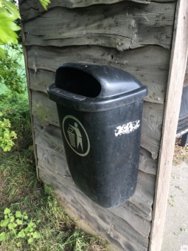 | £75
Royston Road | Solar Powered Traffic Sign | 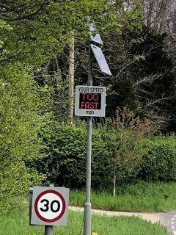 | £4,614
Category | Item | Photograph | Replacement cost as of 31/03/23
Chinnel Meadow | Chinnel Meadow | 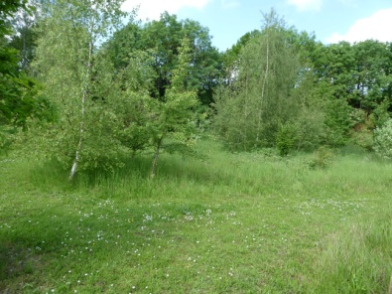 | £1
Chinnel Meadow | Circular tree seat | 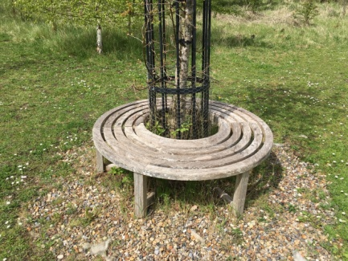 | £4500
Chinnel Meadow | Oak sign | 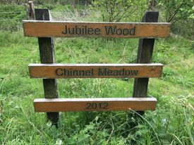 | £550
Chinnel Meadow | Trees (2011) | 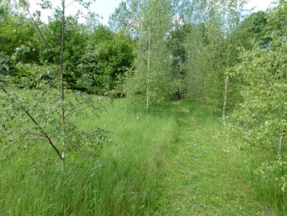 | £1500
Category | Item | Photograph | Replacement cost as of 31/03/23
Chinnel Meadow | Additional trees (2019) | 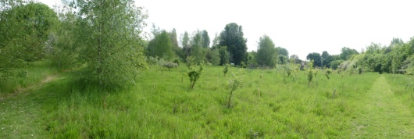  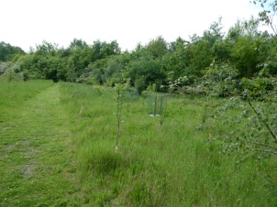 | £280
Chinnel Meadow | Additional trees (2021)  Bramley,  James Grieve, | 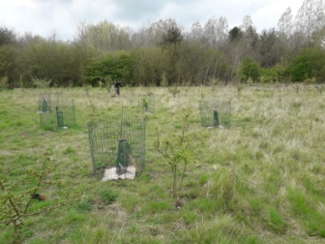  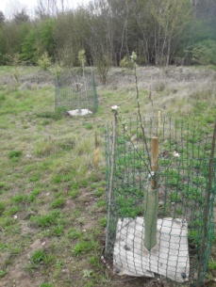 | £60
Village Hall | Defibrillator Enclosure | 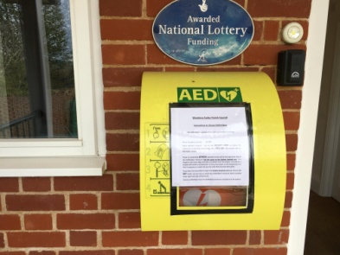 | £650
Village Hall | Defibrillator |  | £750
Category | Item | Photograph | Replacement cost as of 31/03/23
General Village | Green Triangle | 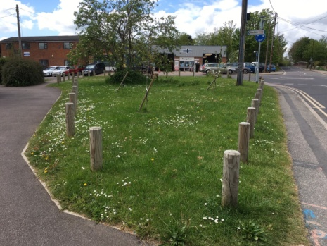 | £1100
General Village | 45 Oak bollards on the green triangle | 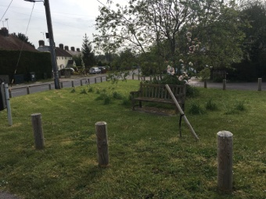
General Village | Trees on the Green Triangle |  | £260
Clerk`s house | HP Laptop | 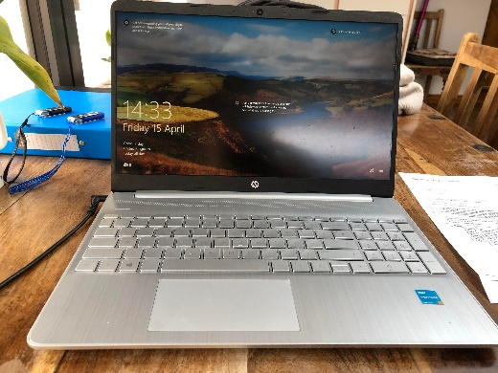 | £625
Category | Item | Photograph | Replacement cost as of 31/03/23
Village Hall | Metal Shed | 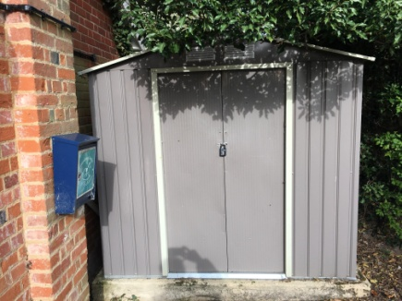 | £385
Village Hall | Notice board | 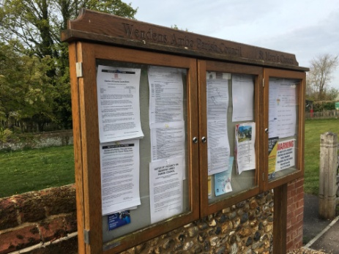 | £1550
The Wick | Goal posts and nets | 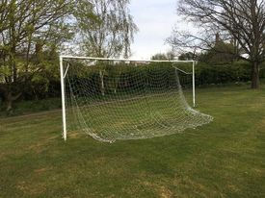  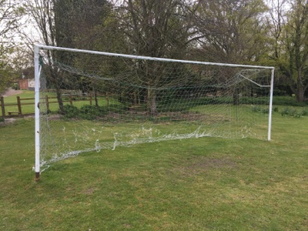 | £650
Category | Item | Photograph | Replacement cost as of 31/03/23
The Wick | Picnic table  (1/2) | 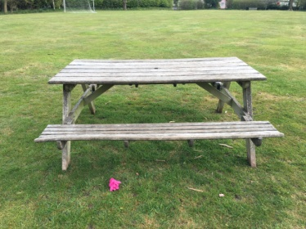 | £1200
The Wick | Picnic table  (2/2) | 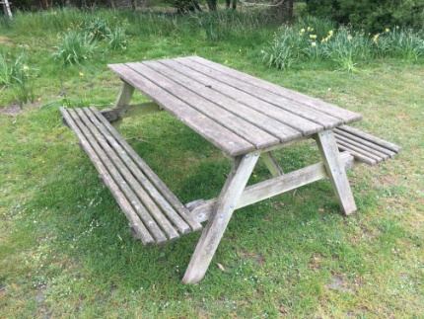 | £1200
The Wick | Play equipment and surfacing | 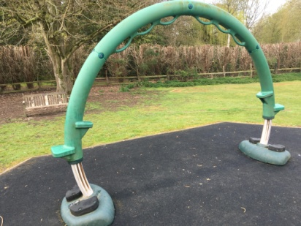  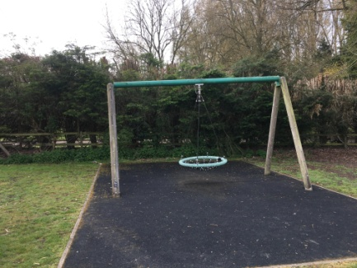  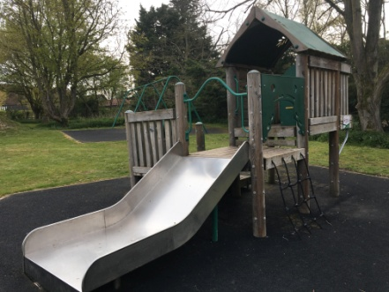  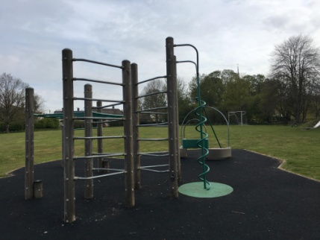  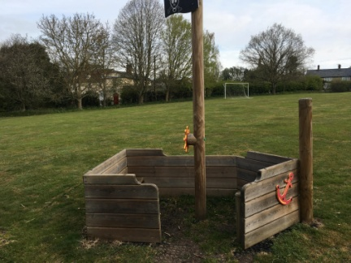  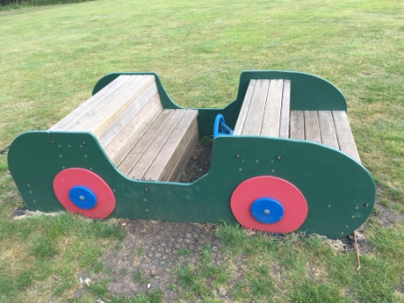  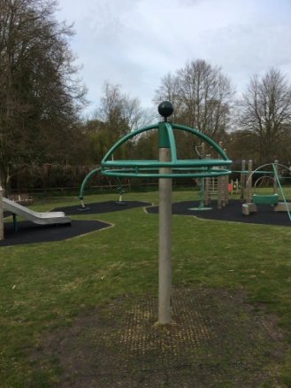  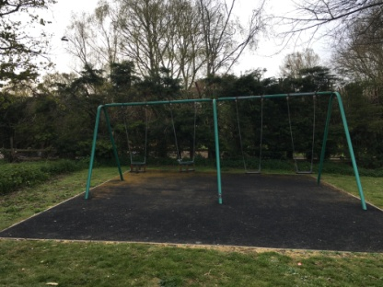  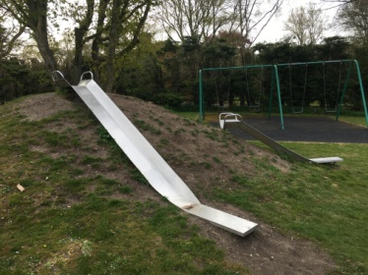 | £71,000
Category | Item | Photograph | Replacement cost as of 31/03/23
The Wick | Gates and Fencing Locking Post | 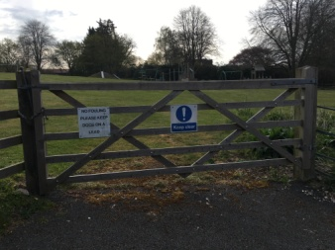  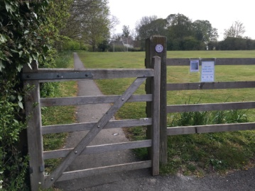  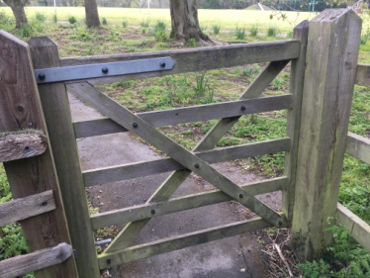 | £3000
The Wick | Memorial Tree and Plaque  Betty Newbold | 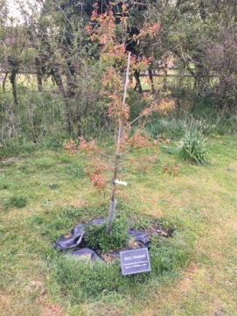 | £100
The Wick | Memorial Tree  Dwayck Beech  Ron Cain |  | £100
Category | Item | Photograph | Replacement cost as of 31/03/23
Duck Street | Telephone box | 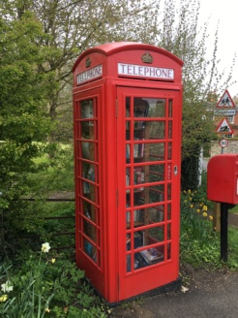 | £1650
Drayton Hill | Traffic mirror | 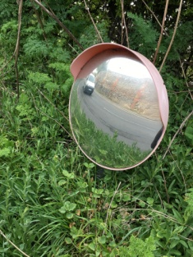 | £220
Rookery Lane | Dog Waste Bin | 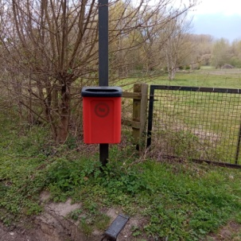 | £130
Rookery Lane | Grit Bin  (1/2) | 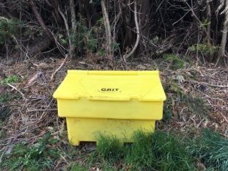 | £75
Category | Item | Photograph | Replacement cost as of 31/03/23
Rookery Lane | Grit Bin  (2/2) | 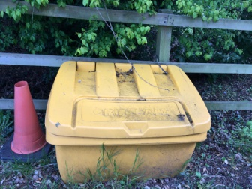 | £100
Cambridge Road | Village stone 1 | 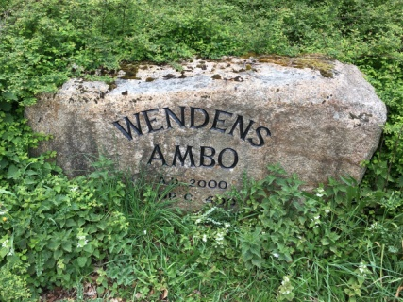 | £750
Royston Road | Village stone 2 | 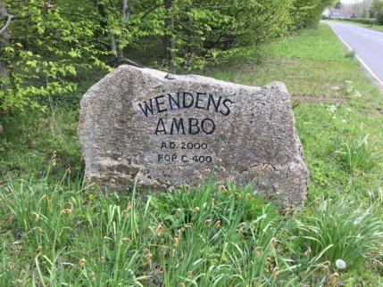 | £750
Clerk`s house | Printer | 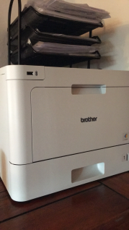 | £300

Total asset register value = £101,110 @ 31/03/23.

